SUPERIOR UNIVERSITY
ARTIFICIAL INTELLIGENCE LAB
LAB 2 – TASK 1
Student Name | Amina Mustafa
Roll Number | 329
Task 1: PEAS Specifications
Objective: Create separate PEAS specifications for a delivery robot and an LLM-based student-support agent. PEAS describes the Performance measure, Environment, Actuators and Sensors of an intelligent agent.
1. Delivery Robot
A delivery robot is an intelligent agent that carries items from a pickup point to a destination. It uses sensors to observe its surroundings and actuators to move and deliver items.
PEAS Component | Details
Performance Measure | Safe delivery; correct destination; timely delivery; avoiding obstacles and damage.
Environment | Campus roads and pathways; buildings; students and pedestrians; obstacles and weather conditions.
Actuators | Wheels or motors for movement; steering mechanism; brakes; robotic arm or delivery compartment.
Sensors | Camera for visual information; GPS for location; ultrasonic or distance sensors for detecting obstacles; proximity sensors.
Constraint / Performance Trade-off
The robot should deliver items quickly, but safety is more important than speed. It may need to slow down or stop when pedestrians or obstacles are nearby. This can increase delivery time but reduces the risk of accidents.
2. LLM-Based Student-Support Agent
An LLM-based student-support agent answers students’ questions about courses, assignments and university information. For this specification, it can read student questions and instructor-approved course documents, but it cannot change grades, submit assignments or access private student records.
PEAS Component | Details
Performance Measure | Correct and relevant answers; clear explanations; timely responses; protecting student privacy.
Environment | Students; university courses; assignment instructions; approved learning materials and FAQs.
Actuators | Display answers in a chat interface; provide links to approved learning resources; ask a clarification question when needed.
Sensors | Student text questions; uploaded course documents; approved FAQ or course-content search results.
Operational Assumptions and Tool Access
The student-support agent can access the student’s current question, files uploaded in the chat, and a read-only collection of instructor-approved course notes and FAQs. It can search these materials and display answers or links. It does not access private student records, change grades, send official university decisions, or submit work on behalf of students. If the available information is insufficient, it should say so rather than invent an answer.
Constraint / Performance Trade-off
The agent should respond quickly, but answer correctness and privacy are more important than speed. It should take time to check approved materials and should avoid giving unsupported answers. This may make some responses slower, but improves reliability and protects students.
Conclusion
PEAS helps describe what an intelligent agent is expected to do and how it interacts with its environment. The delivery robot uses sensors and movement actuators to deliver items safely. The LLM-based student-support agent uses student questions and approved learning materials to provide helpful answers. Both systems must balance their performance goals with important constraints such as safety, accuracy and privacy.
Amina Mustafa | Roll No. 329 | Artificial Intelligence Lab

AI LAB – LAB 2
TASK 2: ENVIRONMENT CLASSIFICATION
Delivery Robot and LLM-Based Student-Support Agent
1. Objective
Classify the delivery robot and LLM-based student-support agent by observability (fully or partially observable) and action outcomes (deterministic or stochastic). Give reasons, examples of observable and hidden variables, and predictable and uncertain outcomes.
2. Operational assumptions
2.1 Delivery robot
The robot operates on a campus with corridors, people, doors, lifts and delivery destinations.
It uses a camera and/or distance sensors, location information and a route map.
It moves using wheels and can report delivery status; it cannot observe every event in the environment.
People may move unexpectedly, routes may become blocked, and sensor readings or localization may be imperfect.
2.2 LLM-based student-support agent
The agent receives student questions as text and can search supplied course FAQs and course materials.
It can produce a text response or ask for clarification. It has no access to private student records, grades or external websites unless separately authorized.
It cannot directly observe the student's full knowledge, intention or understanding.
Questions may be incomplete or ambiguous, and course resources may not cover every question.
3. Classification summary
System | Observability | Action outcomes | Reason
Delivery robot | Partially observable | Stochastic | Sensors show only part of the campus; people and physical movement create uncertainty.
LLM student-support agent | Partially observable | Stochastic | It sees submitted text and accessible resources, not the student's full state; language and responses can be ambiguous or variable.
4. Delivery robot environment
4.1 Observability: Partially observable
The robot is partially observable because its sensors provide information only about areas within their range and field of view. It may detect a person in front of it but not someone approaching around a corner. A map may show a corridor but not a newly placed obstacle.
Observable variable example: distance to an obstacle detected by a distance sensor. Hidden variable example: a person approaching from behind a wall or an obstacle outside the camera's field of view.
4.2 Action outcomes: Stochastic
In the real campus, the same movement command may not always produce the same result. A person may cross the path, a wheel may slip, or a door may be closed unexpectedly.
Predictable outcome example: in a fixed-grid simulator with no moving objects, moving forward one cell always reaches the next cell. Uncertain outcome example: in the real campus, the same command may be slowed or stopped because a person enters the path.
5. LLM-based student-support agent environment
5.1 Observability: Partially observable
The agent can read the student's question and accessible course resources, but it cannot directly observe the student's complete understanding, intention, prior knowledge or circumstances. The question may omit important context.
Observable variable example: the submitted question text and the content of a retrieved course document. Hidden variable example: whether the student understands a concept or which exact step is confusing when it has not been explained.
5.2 Action outcomes: Stochastic
For a deployed LLM system, the interaction is treated as stochastic because natural-language questions can be ambiguous and a response may vary with wording, context or retrieval results. A response may also fail to resolve the student's actual confusion. This assumes generation or retrieval is not guaranteed to return an identical outcome for every equivalent interaction.
Predictable outcome example: in a simplified rule-based simulator, a fixed question such as 'Where can I find the lab timetable?' always returns the same stored FAQ entry. Uncertain outcome example: a vague question such as 'I don't understand task 2' may have different interpretations or require clarification.
6. Real environment versus simplified simulator
A real environment contains incomplete observations and events outside the agent's control. For the robot, people move and physical actions can be affected by obstacles, sensor noise and changing conditions. For the student-support agent, student intent is not fully visible, and language interpretation and response generation may be uncertain.
A simplified simulator can make outcomes more predictable by fixing the map, inputs, rules and action effects. A robot simulator may use a fixed grid with no moving people; a student-support simulator may use fixed question-to-answer rules. Under these restricted assumptions, actions may be deterministic. This does not prove that the real-world environment is deterministic.
7. Conclusion
Under the assumptions in this report, both systems operate in partially observable and stochastic real environments. The robot cannot sense every part of its surroundings, and the student-support agent cannot know the student's complete state from text alone. Their real-world action outcomes can also be uncertain. A simplified simulator may be deterministic when its rules and inputs are fixed, so the model boundary and assumptions must be stated.

AI LAB – LAB 2
TASK 3: STATEFUL CLASSROOM AGENT
Previous-mode memory and command-repeat prevention
1. Objective
Extend the provided smart classroom agent so that it remembers the previous target mode and avoids sending the same control command repeatedly. The original temperature thresholds and occupancy priority are kept unchanged.
2. Design and working
The agent receives two percepts: temperature in degrees Celsius and an occupied Boolean. It first selects a target mode using the original policy: an empty room selects ECO; otherwise, temperature above 26°C selects COOL, temperature below 20°C selects WARM, and all other temperatures select IDLE.
The variable previous_mode stores the last target mode for which a command was sent. If the newly calculated target is different from previous_mode, the agent returns send_command = True and updates previous_mode. If the target is unchanged, it returns send_command = False. On the first percept, previous_mode is None, so the first target is sent as a command.
5. How to run
1. Save the program as lab2_model.py.
2. Open a terminal in the folder containing the file.
3. Run: python lab2_model.py
4. Compare the printed trace with the table above.
6. Conclusion
The stateful agent preserves the original classroom decision policy and adds memory of the previous target mode. It sends a control command only when the target mode changes, reducing unnecessary repeated commands. The tests cover repeated percepts, both exact temperature boundaries, a mode transition, and the empty-room priority case.
Lab 2 – Task 3
7. Code screenshots and execution output
The following screenshots show the stateful ClassroomAgent implementation and its test run. The code stores the previous target mode and sends a command only when the target mode changes.
Figure 1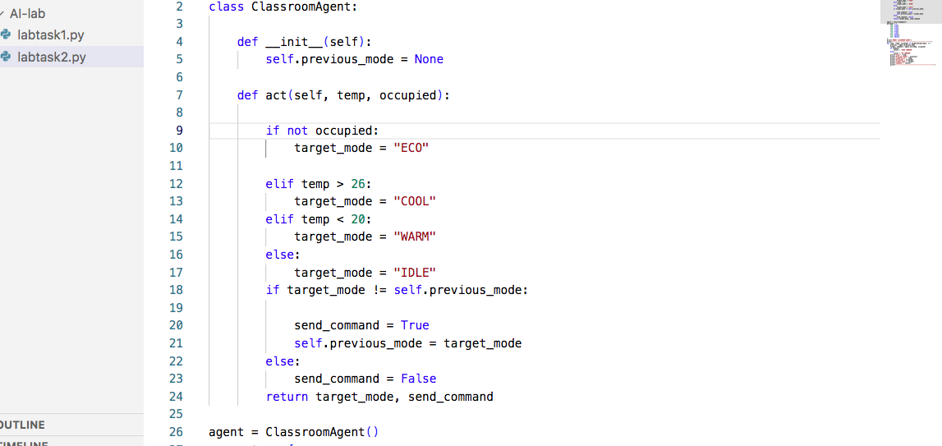. Python code (lab2_model.py)

Figure 2. Program executio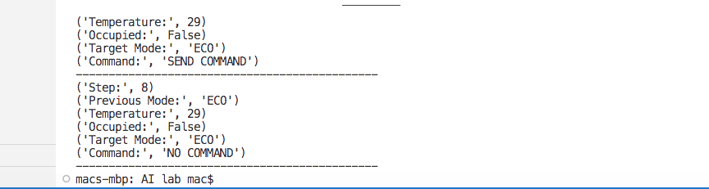n output

